|  |  |
| --- | --- |
| \\VFILERDPI\DPI-Home\OBRIENR2\My Documents\Downloads\PP logo.jpg |  |
| **COUNCIL ASSESSMENT REPORT**  SYDNEY EASTERN CITY PLANNING PANEL | |

|  |  |
| --- | --- |
| PANEL REFERENCE & DA NUMBER | PPSSEC-284 – DA2023/0135 |
| PROPOSAL | Demolition of some existing structures, construction of a new combined facility catering for administration, staff areas, General Learning Spaces, Support Classrooms, Specialty Classrooms, a new Hall and Canteen, refurbishment of the existing library, landscaping and perimeter fencing |
| ADDRESS | 5 Stanley Street, Concord NSW 2127  Includes the following eight (8) lots:  • Lot 1 DP1114919  • Lot 2 DP1114919  • Lot 3 DP1114919  • Lot 1 DP60167  • Lot 15 DP8687  • Lot 18 DP8687  • Lot 19 DP8687  • Lot 20 DP8687 |
| APPLICANT | NSW Department of Education, c/- Barker Ryan Stewart |
| OWNER | NSW Department of Education |
| DA LODGEMENT DATE | 12 July 2023 |
| APPLICATION TYPE | Development Application |
| REGIONALLY SIGNIFICANT CRITERIA | Section 2.19(1) and Clause 4 of Schedule 6 of State Environmental Planning Policy (Planning Systems) 2021 declares the proposal regionally significant development as: Capital Investment Value in excess of $5,000,000.00 |
| CIV | $49,449,610.00 (inclusive GST) |
| CLAUSE 4.6 REQUESTS | Clause 4.3 Height of Buildings pursuant to the Canada Bay Local Environmental Plan 2013 to be varied. Site is located within an R3 medium density residential zone. |
| KEY SEPP/LEP | State Environmental Planning Policy (Biodiversity and Conservation) 2021  State Environmental Planning Policy (Planning Systems) 2021  State Environmental Planning Policy (Resilience and Hazards) 2021  State Environmental Planning Policy (Transport and Infrastructure) 2021  Canada Bay Local Environmental Plan 2013 |
| TOTAL & UNIQUE SUBMISSIONS KEY ISSUES IN SUBMISSIONS | None |
| DOCUMENTS SUBMITTED FOR CONSIDERATION | Architectural Plans  Civil and Stormwater Management Plans  Survey Plan  Landscaping Plan  Statement of Heritage Impact  Preliminary Site Investigation (Contamination)  Detailed Site Investigation (Contamination)  Clause 4.6 Variation Report  Operational Waste Management Plan  Demolition and Construction Waste Management Plan  Remediation Action Plan  Arboricultural Development Impact Assessment Report  Transport and Traffic Assessment  Preliminary Indigenous Heritage and Impact Assessment  Acid Sulfate Soils Management Plan  Flood Study / Overland Flow Assessment  Design Verification Statement  BCA and Access Report  Noise and Vibration Impact Assessment  School Transport Plan |
| SPECIAL INFRASTRUCTURE CONTRIBUTIONS (S7.24) | N/A |
| RECOMMENDATION | Approval |
| DRAFT CONDITIONS TO APPLICANT | YES |
| SCHEDULED MEETING DATE | 8 February 2024 |
| PLAN VERSION | Several – as per condition 1 |
| PREPARED BY | Edna Sorensen |
| DATE OF REPORT | 24 January 2024 |

**EXECUTIVE SUMMARY**

The development application (DA2023/0135) seeks consent for demolition of some existing structures, construction of a new combined facility catering for administration, staff areas, General Learning Spaces, Support Classrooms, Specialty Classrooms, a new Hall and Canteen, refurbishment of the existing library, landscaping and perimeter fencing. The proposal will accommodate an increase in students from 1,335 to 1,360 and increase in staff numbers from 89 to 95 full time equivalent.

The application is a Crown development application, which is a development application made by or on behalf of the Crown. School Infrastructure NSW (SINSW) is part of the NSW Department of Education and is a statutory body representing the Crown.

The subject site is known as 5 Stanley Street, Concord NSW 2127 and comprises eight (8) lots with road frontages to Crane Street to the north and Stanley Street to the south and occupies an area of 32,625sqm. To the east, the site adjoins St Lukes Oval. There are two vehicle access points to the site, one from either street frontage.

The subject site is located within the R3 Medium Density Residential zone under Canada Bay Local Environmental Plan (CBLEP) 2013. The subject site is currently utilised for the purposes of an educational establishment being the Concord High School. Educational facilities is a development type permissible with consent in the R3 zone under the CBLEP2013.

The existing school buildings date back to late 1970s/early 1980s and have been adapted over time to meet the changing needs of the school community and sit within a landscaped setting with the school grounds listed as a heritage item on the NSW Government Section 170 Register and the CBLEP 2013.

The site has access to water and sewer systems and electrical and telecommunications services. The site has pedestrian access from both Stanley Street and Crane Street. Vehicular access to the existing car parks is provided from Stanley Street with service vehicles entering the site from Crane Street.

The proposal is seeking a variation to the Building Height Development Standard prescribed under the Canda Bay Local Environmental Plan 2013. The variation is supported by a well-founded Clause 4.6 objection.

The proposal has been considered against the provisions of relevant Environmental Planning Instruments including State Environmental Planning Policy (Biodiversity and Conservation) 2021, State Environmental Planning Policy (Planning Systems) 2021, State Environmental Planning Policy (Resilience and Hazards) 2021, State Environmental Planning Policy (Transport and Infrastructure) 2021 and Canada Bay Local Environmental Plan 2013 and is generally consistent with the prescribed aims and objectives of these instruments.

There were no concurrence requirements from agencies for the proposal and the application is not integrated development pursuant to Section 4.46 of the *Environmental Planning and Assessment Act 1979* (‘EP&A Act’)*.*

The development application required referral to NSW Transport under SEPP (Transport and Infrastructure) 2021, s2.119 (Development with frontage to classified road) who raised no objections subject to the submitted School Travel Plan is updated as per their recommendations. The development was also referred to the Canada Bay Design Review Panel.

The proposal was notified in accordance with the Council’s Community Participation Plan from 13 July 2023 until 3 August 2023 with no submission being received.

The application is referred to the Sydney Eastern City Planning Panel (‘the Panel’) as the development is ‘*regionally significant development’*, pursuant to Section 2.19(1) and Clause (5)(b) of Schedule 6 of *State Environmental Planning Policy (Planning Systems) 2021* as the proposal is development for educational *facilities* with a CIV over $5 million.

A briefing was held with the Panel on 9 November 2023 where key issues were discussed, including tree removal, onsite parking and non-compliant building height. The Panel requested the applicant to submit a Tree Canopy Cover Plan and give consideration to the use of permeable surface to additional car parking spaces enabling retention of trees in this area.

Key issues are resolved/justified as discussed within this report.

Following consideration of the matters for consideration under Section 4.15(1) of the EP&A Act, the provisions of the relevant State environmental planning policies, the proposal is recommended for approval.

1. **THE SITE AND LOCALITY**
   1. **The Site**

The site is located at 5 Stanley Street, Concord and is comprised of eight different lots being lots, 1, 2 and 3 in DP1114919, lot 1 in DP60167 and lots 15, 18, 19 and 20 in DP8687. The site covers a total area of 32,625sqm.

To the north, the site is bound by Crane Street with an R2 low density residential zone beyond, and to the south, the site is bound by Stanley Street, an R3 medium density residential zone and St Luke’s Park, and to the east, St Luke’s Oval. To the west, the site adjoins Crane Lane and medium density residential and E1 local centre zones.

Existing staff car parking is located to the south-west and south-east of the site and accessed from Stanley Street and to the north, there is a vehicle access point for waste and services vehicles.

The site has a level difference of approximately 5-6m sloping down in a north-west to south-east direction and contains several mature trees and clusters of vegetation throughout the site.

The Concord High School grounds are local heritage listed and identified on the NSW Government Section 170 Register and the CBLEP 2013.

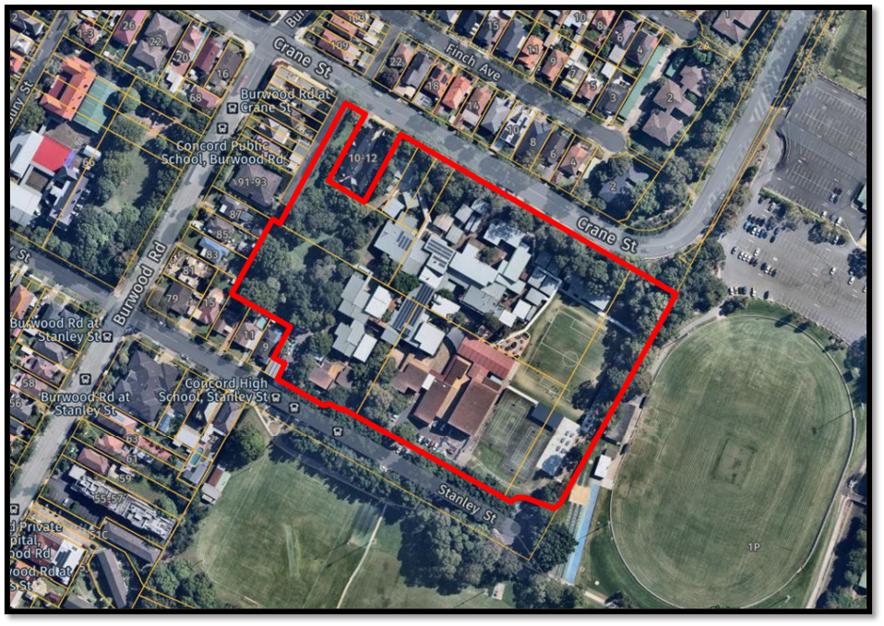

***Figure 1:*** *Aerial photograph showing the subject site outlined in red.*

* 1. **The Locality**

Surrounding development is a mix of residential development of various scale, age and typology as well as neighbourhood shops. Concord Public School is located further west along Stanley Street on the northern side of the street at the corner with Burwood Road.

Stanley Street is largely defined in the west by single dwelling residential development of one to two storeys in height which extends to three storeys within the residential flat building on the corner of Burwood Road and Stanley Street. The eastern end of Stanley Street supports single dwelling development, Concord High School and public open space elements including St Luke’s Oval and Cintra Park. A row of mature heritage listed Fig trees line the southern sides of Stanley Street

Crane Street to the north of the site supports a mix of single dwelling residential development and taller residential flat buildings of three storeys in height. A defined tree canopy is evident along the northern boundary of the school site with mature street trees also scattered along the northern side of the Crane Street road reserve. A large at-grade car park exists to the northeast of the site servicing St Luke’s Oval and surrounds.

Nearby public transport includes bus stops located along Burwood Road to the west and immediately outside the site along Stanley Street. Strathfield Railway Station is located approximately 1.4 kilometres to the south-west of the site.

1. **THE PROPOSAL AND BACKGROUND** 
   1. **The Proposal**

The proposal seeks consent for the demolition of some existing structures, construction of a new combined facility catering for administration, staff areas, General Learning Spaces (GLS), Support Classrooms, Specialty Classrooms, a new Gymnasium / Hall and Canteen, refurbishment of the existing library, landscaping and perimeter fencing.

Specifically, the proposal involves:

* Demolition of existing Block E, the adjacent existing car park and the existing games courts in the south-east of the site.
* Removal of a total of 46 trees including 1 street tree
* Construction of three new Blocks being:

* Block X, incorporating a new hall/ gymnasium
* Block Y, including a canteen, movement studio, performing arts and physical education facilities
* Block Z, which comprises a new four-storey building containing staff and administration facilities, support learning, visual arts workshop, and GLS
* Provision of new games courts to the northeast of the site adjacent to Crane Street
* Western car park upgrade and extension to offset the loss of the existing car park referred to above within the development footprint providing a total of 29 on-site spaces including 1 accessible space
* Landscape works including new tiered seating adjacent to the existing sports field
* Light refurbishment of Block A library facilities
* The relocation of modular Block I (uniform shop) to the west of the western car park and provision of access complaint ramp
* Upgrade to existing and provision of new footpaths connecting buildings and services within site
* Stormwater infrastructure
* Increase in Staff and Students as follows:
* 1,360 students (increase of 25 students); and
* 95 staff (increase of 6 staff - full time equivalent).
* Bicycle and scooter spaces provided as follows:
* 14 x staff bicycle spaces within existing Block G.
* 96 bicycle spaces and 16 scooter spaces located adjacent to new Blocks X, Y, and Z; and
* 60 bicycle spaces and 16 scooter spaces located within the northeast of the site adjacent to St Luke’s oval.

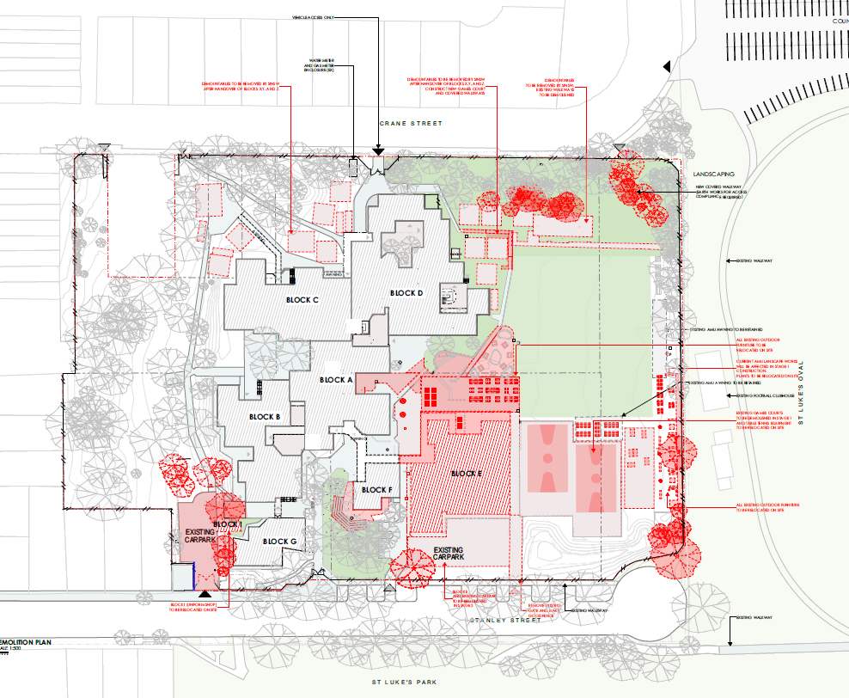***Figure 2:*** *Demolition Plan showing existing buildings, structures and trees to be removed.*

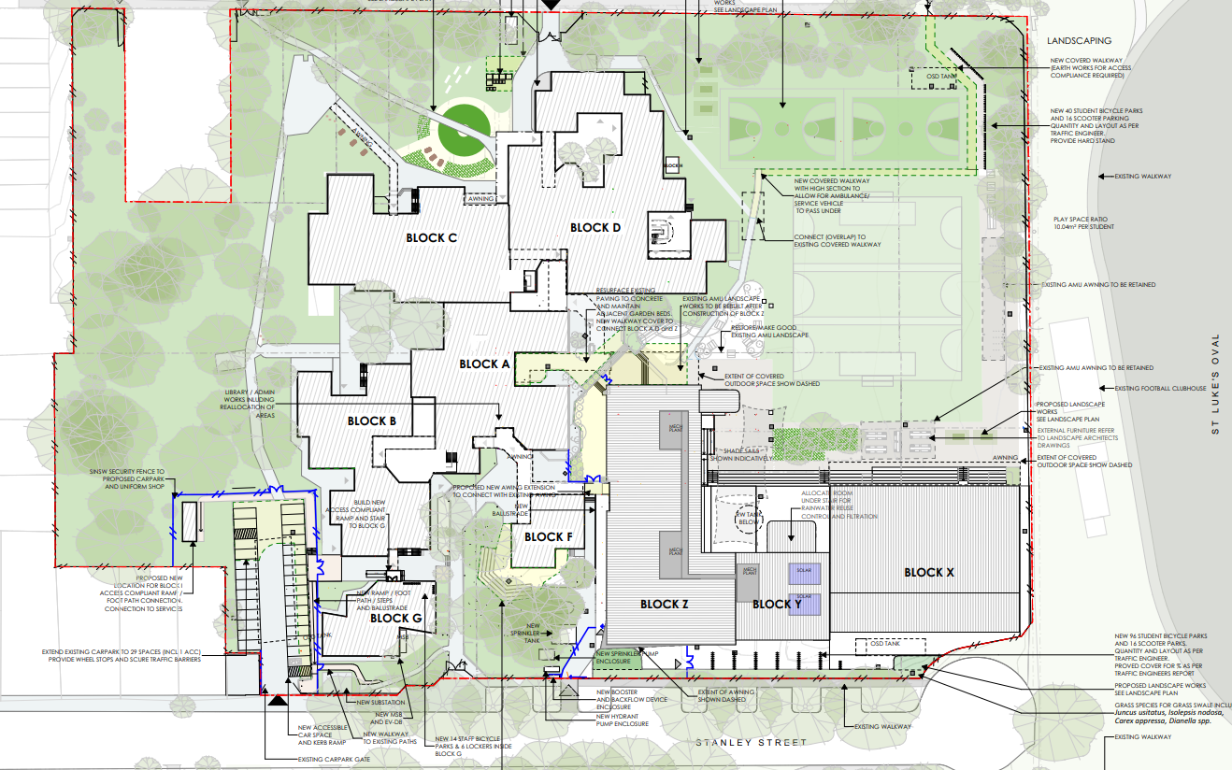

***Figure 3:*** *Site Plan showing the subject site outlined in red and the proposed development.*

**Table 1: Development Data**

|  |  |
| --- | --- |
| Control | Proposal |
| Site area | 32,625sqm |
| FSR | Maximum FSR applicable - 0.50:1  FSR proposed: 0.50:1 |
| Clause 4.6 Requests | Yes  Request to vary Clause 4.3 Height of Buildings |
| Max Height | Maximum height applicable - 8.5m  Height proposed – 18.29m  Non-compliance – 115% |
| Car Parking spaces | Council’s DCP does not provide parking rates for educational establishments.29 on-site parking spaces including 1 accessible space proposed (currently 40 onsite parking spaces exist; proposal results in loss of 11 spaces) |

* 1. **Background**

The development application was lodged on 12 July 2023. A chronology of the development application is outlined below including the Panel’s involvement (briefings, deferrals etc) with the application:

**Table 2: Chronology of the DA**

|  |  |
| --- | --- |
| **Date** | **Event** |
| 12 July 2023 | DA lodged |
| 13 July 2023 | Exhibition of the development application |
| 13 July 2023 | DA referral to external agencies |
| 9 August 2023 | Referral comments were emailed to the applicant (arborist, landscape, heritage, building, TfNSW, stormwater and noise/ ASS/ contamination)  Council advised applicant that it would be beneficiary to have the Canada Bay DRP review the proposal although this is not a legislative requirement. |
| 31 August 2023 | Panel Kick Off Briefing Meeting  Panel requested the DA to be reviewed by the Canada Bay Design Review Panel. |
| 20 September 2023 | Canada Bay DRP reviewed the DA and provided comments. |
| 4 October 2023 | DRP Minutes forwarded to the applicant. |
| 13 October 2023 | Council confirmed it would not issue a formal RFI as there are no additional issues to those outlined in the referral comments already provided to the applicant. |
| 9 November 2023 | Panel Briefing Meeting |
| 10 November 2023 | Applicant uploads RFI response package to the portal |
| 11 January 2024 | Draft Conditions forwarded to applicant |
| 19 January 2024 | Applicant uploads amended stormwater plans and amended Remedial Action Plan to the Portal. |

1. **STATUTORY CONSIDERATIONS**

When determining a development application, the consent authority must take into consideration the matters outlined in Section 4.15(1) of the *Environmental Planning and Assessment Act 1979* (‘EP&A Act’). These matters as are of relevance to the development application include the following:

1. *the provisions of any environmental planning instrument, proposed instrument, development control plan, planning agreement and the regulations*

*(i)  any environmental planning instrument, and*

*(ii)  any proposed instrument that is or has been the subject of public consultation under this Act and that has been notified to the consent authority (unless the Planning Secretary has notified the consent authority that the making of the proposed instrument has been deferred indefinitely or has not been approved), and*

*(iii)  any development control plan, and*

*(iiia)  any planning agreement that has been entered into under section 7.4, or any draft planning agreement that a developer has offered to enter into under section 7.4, and*

*(iv)  the regulations (to the extent that they prescribe matters for the purposes of this paragraph),*

*that apply to the land to which the development application relates,*

1. *the likely impacts of that development, including environmental impacts on both the natural and built environments, and social and economic impacts in the locality,*
2. *the suitability of the site for the development,*
3. *any submissions made in accordance with this Act or the regulations,*
4. *the public interest.*

These matters are further considered below.

The proposal required referral to TfNSW for review and comments as considered further in this report.

* 1. **Environmental Planning Instruments, proposed instrument, development control plan, planning agreement and the regulations**

The relevant environmental planning instruments, proposed instruments, development control plans, planning agreements and the matters for consideration under the Regulation are considered below.

1. **Section 4.15(1)(a)(i) - Provisions of Environmental Planning Instruments**

The following Environmental Planning Instruments are relevant to this application:

* [State Environmental Planning Policy (Biodiversity and Conservation) 2021](https://legislation.nsw.gov.au/view/html/inforce/current/epi-2021-0722)
* [State Environmental Planning Policy (Planning Systems) 2021](https://legislation.nsw.gov.au/view/html/inforce/current/epi-2021-0724)
* [State Environmental Planning Policy (Resilience and Hazards) 2021](https://legislation.nsw.gov.au/view/html/inforce/current/epi-2021-0730)
* [State Environmental Planning Policy (Transport and Infrastructure) 2021](https://legislation.nsw.gov.au/view/html/inforce/current/epi-2021-0732)
* Canada Bay Local Environmental Plan 2013

A summary of the key matters for consideration arising from these State Environmental Planning Policies are outlined in **Table 3** and considered in more detail below.

**Table 3: Summary of Applicable Environmental Planning Instruments**

|  |  |  |
| --- | --- | --- |
| **EPI** | **Matters for Consideration** | **Comply (Y/N)** |
| State Environmental Planning Policy (Biodiversity & Conservation) 2021 | Chapter 2: Vegetation in non-rural areas  Chapter 6: Water Catchment | Y |
| State Environmental Planning Policy (Planning Systems) 2021 | Chapter 2: State and Regional Development   * Section 2.19(1) declares the proposal regionally significant development pursuant to Clause 4 of Schedule 6 as it comprises Capital Investment Value in excess of $5,000,000.00. | Y |
| SEPP (Resilience & Hazards) | Chapter 4: Remediation of Land  Section 4.6 - Contamination and remediation have been considered in the Contamination Report | Y |
| State Environmental Planning Policy (Transport and Infrastructure) 2021 | Chapter 3: Educational Establishments   * Section 3.4 – Schools — matters for consideration by consent authorities. | Y |
| Proposed Instruments | Compliance issues identified. | Y |
| LEP | * Clause 2.3 – Permissibility and zone objectives * Clause 4.3 – Height of Buildings | Y  No –refer to key issues |
| DCP | Part B - General Controls - Table B-D Accessible Parking Requirements  Appendix 2 – Engineering Specification | Y  Y |

Consideration of the relevant SEPPs is outlined below:

* [*State Environmental Planning Policy (Biodiversity and Conservation) 2021*](https://legislation.nsw.gov.au/view/html/inforce/current/epi-2021-0722)

Chapter 2: Vegetation in non-rural areas

Chapter 2 seeks to protect the biodiversity values of the State and to preserve the amenity of non-rural areas through the preservation of trees and other vegetation. The chapter applies to land in the Canada Bay LGA and the R3 Medium Density Residential zone, both of which apply to the proposal.

A number of trees are proposed to be removed as part of this application. In response to original comments made by Council’s arborist and landscape architect, additional information was submitted. Based on the applicant’s additional information/response, no further issues are raised.

Chapter 6: Water Catchment

The site is located within the Sydney Harbour Catchment and Chapter 6 applies.

Due to the distance from the foreshore, approximately 560m, the proposal will not impact on the water quality and quantity of the waterways, the aquatic ecology, generate flooding, impact on recreation and public access to the foreshore or have any detrimental impact on downstream LGA’s or any unacceptable impact upon views and vistas to and from the foreshore/waterways.

It is considered that the proposal satisfies the matters of consideration.

* [*State Environmental Planning Policy (Planning Systems) 2021*](https://legislation.nsw.gov.au/view/html/inforce/current/epi-2021-0724) *(‘*Planning Systems SEPP’)

Chapter 2: State and Regional Development

Schedule 6 of this SEPP provides that any Crown Development with a CIV of more than $5 million is Regional Significant Development. The CIV meets the $5 million threshold, and the DA will be assessed as Regionally Significant Development for determination by the Sydney Eastern City Planning Panel.

* [*State Environmental Planning Policy (Resilience and Hazards) 2021*](https://legislation.nsw.gov.au/view/html/inforce/current/epi-2021-0730)

Chapter 4: Remediation of Land

The provisions of Chapter 4 of *State Environmental Planning Policy (Resilience and Hazards) 2021 (‘the* Resilience and Hazards SEPP’) have been considered in the assessment of the development application. Section 4.6 of Resilience and Hazards SEPP requires consent authorities to consider whether the land is contaminated, and if the land is contaminated, it is satisfied that the land is suitable in its contaminated state (or will be suitable, after remediation) for the purpose for which the development is proposed to be carried out.

A Preliminary Site Investigation (PSI) was prepared by Environmental Australia on behalf of SINSW for contamination on the site. The preliminary assessment noted that the site had historically been used as a tannery prior to 1967 when the land was purchased by the NSW Department of Education for the construction of Concord High School.

A Detailed Site Investigation (DSI) was subsequently prepared, also by Environmental Australia. The DSI included a soil investigation, groundwater monitoring well installation and groundwater sampling and made several recommendations that prompted the preparation of a Remediation Action Plan.

An Acid Sulphate Soils Management Plan has also been prepared to address some of the recommendations identified in the RAP.

Council’s environmental health officer reviewed the aforementioned reports and raised no objections to the approval of the development application subject to relevant conditions of consent which they provided. These conditions form part of the recommendation for approval of the development application.

* [*State Environmental Planning Policy (Transport and Infrastructure) 2021*](https://legislation.nsw.gov.au/view/html/inforce/current/epi-2021-0732)

Chapter 3: Educational Establishments

Section 3.4 – Schools – matters for consideration by consent authorities.

|  |  |
| --- | --- |
| ***Relevant Clause*** | ***Response*** |
| *3.34 Interpretation*  *-definition*  *-prescribed zoning* | The school is an existing school, and the site is located in the R3 zone, which is a prescribed zone within the meaning of this Part. |
| *3.36 Schools—development permitted with consent*  *(1) Development for the purpose of a school may be carried out by any person with development consent on land in a prescribed zone.*  *(2) Development for a purpose specified in section 3.40(1) or 3.41(2)(e) may be carried out by any person with development consent on land within the boundaries of an existing or approved school.*  *(3) Development for the purpose of a school may be carried out by any person with development consent on land that is not in a prescribed zone if it is carried out on land within the boundaries of an existing or approved school.*  *(4) Subsection (3) does not require development consent to carry out development on land if that development could, but for this Chapter, be carried out on that land without development consent.*  *(5) A school (including any part of its site and any of its facilities) may be used, with development consent, for the physical, social, cultural or intellectual development or welfare of the community, whether or not it is a commercial use of the establishment.*  *(6) Before determining a development application for development of a kind referred to in subsection (1), (3) or (5), the consent authority must take into consideration—*  *(a) the design quality of the development when evaluated in accordance with the design quality principles set out in Schedule 8, and*  *(b) whether the development enables the use of school facilities (including recreational facilities) to be shared with the community.*  *(7) Subject to subsection (8), the requirement in subsection (6)(a) applies to the exclusion of any provision in another environmental planning instrument that requires, or that relates to a requirement for, excellence (or like standard) in design as a prerequisite to the granting of development consent for development of that kind.*  *(8) A provision in another environmental planning instrument that requires a competitive design process to be held as a prerequisite to the granting of development consent does not apply to development to which subsection (6)(a) applies that has a capital investment value of less than $50 million.*  *(9) A provision of a development control plan that specifies a requirement, standard or control in relation to development of a kind referred to in subsection (1), (2), (3) or (5) is of no effect, regardless of when the development control plan was made.*  *(10) Development for the purpose of a centre-based child care facility may be carried out by any person with development consent on land within the boundaries of an existing or approved school.* | The proposed works are provided for under section 3.40(1) of the SEPP and may be carried out with consent within the existing school site.  The subject site is both an existing school and within a prescribed zone.  The subject site is an existing school and within a prescribed zone.  Noted  Noted  A Design Verification Statement has been prepared and submitted to Council confirming the proposal is consistent with the design quality principles set out in Schedule 8 of the SEPP. The proposal has also been reviewed by the Canada Bay Design Review Panel.  The applicant’s submitted documentation verifies that the community will be able to continue to use school facilities.  As per the below, a competitive design process is not required. The proposal has considered the 7 Education SEPP Design Quality Principles.  The proposed development has a capital investment value (CIV) of less than the $50 million threshold. A competitive design process is therefore not required.  Noted however the CBDCP has been considered as part of a comprehensive assessment.  Noted however proposal does not include a centre based childcare facility. |
| *Part 3.7 General development controls*  *3.58 Traffic-generating development*  *(1) This section applies to development for the purpose of an educational establishment—*  *(a) that will result in the educational establishment being able to accommodate 50 or more additional students, and*  *(b) that involves—*  *(i) an enlargement or extension of existing premises, or*  *(ii) new premises,*  *on a site that has direct vehicular or pedestrian access to any road.*  *(2) Before determining a development application for development to which this section applies, the consent authority must—*  *(a) give written notice of the application to Transport for NSW (TfNSW) within 7 days after the application is made, and*  *(b) take into consideration the matters referred to in subsection (3).*  *(3) The consent authority must take into consideration—*  *(a) any submission that TfNSW provides in response to that notice within 21 days after the notice was given (unless, before the 21 days have passed, TfNSW advises that it will not be making a submission), and*  *(b) the accessibility of the site concerned, including—*  *(i) the efficiency of movement of people and freight to and from the site and the extent of multi-purpose trips, and*  *(ii) the potential to minimise the need for travel by car, and*   1. *any potential traffic safety, road congestion or parking implications of the development.*   *(4) The consent authority must give TfNSW a copy of the determination of the application within 7 days after the determination is made.* | Noted however the proposal does not apply as the proposal does not increase student numbers by 50 or more students.  The application was referred to TfNSW for comments within 7 days of it being lodged.  See below  The comments made by TfNSW have been included in the recommended conditions of consent.  A transport and Traffic Assessment and School travel plan has been submitted and reviewed by Council’s traffic engineer and TfNSW.  Noted |

* *Canada Bay Local Environmental Plan 2013*

The relevant local environmental plan applying to the site is the *Canada Bay Local Environmental Plan 2013* (‘the LEP’). The aims of the LEP are to make local environmental planning provisions for land in Canada Bay in accordance with the relevant standard environmental planning instrument under section 3.20 of the Act.

*Zoning and Permissibility (Part 2)*

The site is located within the R3 Medium Density Zone pursuant to Clause 2.2 of the LEP.

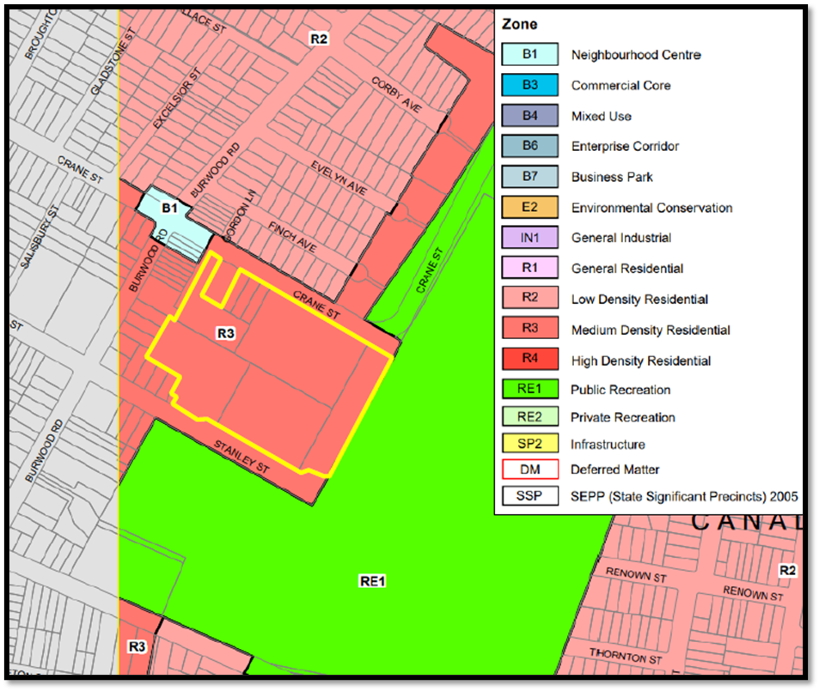

***Figure 4:*** *Zoning Map showing the subject site outline in red located within an R3 Medium Density Residential zone.*

According to the definitions in Clause 4 (contained in the Dictionary), the proposal satisfies the definition of School which is a permissible use with consent in the Land Use Table in Clause 2.3.

The zone objectives include the following (pursuant to the Land Use Table in Clause 2.3):

* *To provide for the housing needs of the community within a medium density residential environment.*
* *To provide a variety of housing types within a medium density residential environment.*
* *To enable other land uses that provide facilities or services to meet the day to day needs of residents.*

The proposal is not defined as residential development and the first two objectives are therefore not relevant. The proposal is consistent with the third objective in that it provides for a land use that provides a facility and service that meets the educational needs of existing and future residents.

*General Controls and Development Standards (Part 2, 4, 5 and 6)*

The LEP also contains controls relating to development standards, miscellaneous provisions and local provisions. The controls relevant to the proposal are considered in **Table 4** below.

The proposal does not comply with the development standard in Part 4 of the LEP/Clause 4.3(2) Height of Buildings and accordingly, a Clause 4.6 request has been provided with the application for the exceedance of the maximum Building Height DEVELOPMENT STANDARD.

**Table 4: Consideration of the LEP Controls**

|  |  |  |  |
| --- | --- | --- | --- |
| **Control** | **Requirement** | **Proposal** | **Comply** |
| Height of buildings  (Cl 4.3(2)) | Maximum height applicable to site – 8.5m | 18.29m | No (supported with Clause 4.6 objection) |
| FSR  (Cl 4.4(2)) | Maximum floor space ratio for the site - 0.5:1. | 0.50:1 | Yes |
| Heritage  (Cl 5.10) | Development consent is required for any of the following—   1. demolishing or moving any of the following or altering the exterior of any of the following (including, in the case of a building, making changes to its detail, fabric, finish or appearance) -   (i) a heritage item,  (ii) an Aboriginal object,  (iii) a building, work, relic or tree within a heritage conservation area,   1. altering a heritage item that is a building by making structural changes to its interior or by making changes to anything inside the item that is specified in Schedule 5 in relation to the item, 2. disturbing or excavating an archaeological site while knowing, or having reasonable cause to suspect, that the disturbance or excavation will or is likely to result in a relic being discovered, exposed, moved, damaged or destroyed, 3. disturbing or excavating an Aboriginal place of heritage significance, 4. erecting a building on land -   (i) on which a heritage item is located or that is within a heritage conservation area, or  (ii) on which an Aboriginal object is located or that is within an Aboriginal place of heritage significance,   1. subdividing land -   (i) on which a heritage item is located or that is within a heritage conservation area, or  (ii) on which an Aboriginal object is located or that is within an Aboriginal place of heritage significance. | The proposal involves the removal of trees which forms part of the site’s heritage listed landscape setting. | Yes (As discussed further in this report, the proposal will have minimal impact on the heritage listed landscape setting on the site) |
| Flood Planning  (Cl 5.21) | Development consent must not be granted to development on land the consent authority considers to be within the flood planning area unless the consent authority is satisfied the development—   1. is compatible with the flood function and behaviour on the land, and 2. will not adversely affect flood behaviour in a way that results in detrimental increases in the potential flood affectation of other development or properties, and 3. will not adversely affect the safe occupation and efficient evacuation of people or exceed the capacity of existing evacuation routes for the surrounding area in the event of a flood, and 4. incorporates appropriate measures to manage risk to life in the event of a flood, and 5. will not adversely affect the environment or cause avoidable erosion, siltation, destruction of riparian vegetation or a reduction in the stability of river banks or watercourses. | The submitted Flood Impact Assessment Report dated 1 June 2023 prepared by Woolacotts advised the proposed development is affected by the 1% Annual Exceedance Probability (AEP) storm event. | Yes  Council’s stormwater engineer raised no issues subject to relevant conditions of consent. |
| Acid sulphate soils  (Cl 6.1) | Development consent is required for the carrying out of works described in the Table to this sub-clause on land shown on the Acid Sulfate Soils Map as being of the class specified for those works.  Class 5 is defined as works within 500m of adjacent Class 1, 2, 3 or 4 land that is below 5m Australian Height Datum and by which the watertable is likely to be lowered below 1m Australian Height Datum on adjacent Class 1, 2, 3 or 4 land. | The site is located on class 2 and class 5 lands. | Yes  Council’s environmental health officer reviewed the application and raised no issues subject to conditions of consent. |
| Earthworks  (Cl 6.2) | Before granting development consent for earthworks (or for development involving ancillary earthworks), the consent authority must consider the following matters -   1. the likely disruption of, or any detrimental effect on, drainage patterns and soil stability in the locality of the development, 2. the effect of the development on the likely future use or redevelopment of the land, 3. the quality of the fill or the soil to be excavated, or both, 4. the effect of the development on the existing and likely amenity of adjoining properties, 5. the source of any fill material and the destination of any excavated material, 6. the likelihood of disturbing relics, 7. the proximity to, and potential for adverse impacts on, any waterway, drinking water catchment or environmentally sensitive area, 8. any appropriate measures proposed to avoid, minimise or mitigate the impacts of the development. | Extensive earthwork is not proposed, and the proposal will not have a detrimental impact on any listed matters for consideration. | Yes |

With the exception of the non-compliant building height, the proposal is considered to be consistent with the LEP.

Clause 4.6 – Exemption of Development Standards

1. *The objectives of this clause are:* 
   1. *to provide an appropriate degree of flexibility in applying certain development standards to particular development, and*
   2. *to achieve better outcomes for and from development by allowing flexibility in particular circumstances.*
2. *Consent may, subject to this clause, be granted for development even though the development would contravene a development standard imposed by this or any other environmental planning instrument. However, this clause does not apply to a development standard that is expressly excluded from the operation of this clause.*
3. *Consent must not be granted for development that contravenes a development standard unless the consent authority has considered a written request from the applicant that seeks to justify the contravention of the development standard by demonstrating:* 
   1. *that compliance with the development standard is unreasonable or unnecessary in the circumstances of the case, and*
   2. *that there are sufficient environmental planning grounds to justify contravening the development standard.*
4. *Consent must not be granted for development that contravenes a development standard unless:* 
   * + - 1. *the consent authority is satisfied that:*
     1. *the applicant’s written request has adequately addressed the matters required to be demonstrated by subclause (3), and*
     2. *the proposed development will be in the public interest because it is consistent with the objectives of the particular standard and the objectives for development within the zone in which the development is proposed to be carried out, and*

*(b) the concurrence of the Director-General has been obtained.*

1. *In deciding whether to grant concurrence, the Director-General must consider:* 
   1. *whether contravention of the development standard raises any matter of significance for State or regional environmental planning, and*
   2. *the public benefit of maintaining the development standard, and*
   3. *any other matters required to be taken into consideration by the Director-General before granting concurrence.*
2. What Clause is sought to be varied:

Clause 4.3(2) of the Canada Bay Local Environmental Plan 2013 (CBLEP 2013) states that *the height for a building on any land is not to exceed the maximum height shown for the land on the Height of Buildings Map.* The Height of Buildings Map shows that the maximum building height permitted for a building on the subject land is 8.5m. The proposed development has a height of 18.29m exceeding the development standard by 9.79m or 115%.

1. Clause 4.6 Objectives:

The following objectives are contained in Clause 4.6 of the Canada Bay Local Environmental Plan 2013:-

*(a) to provide an appropriate degree of flexibility in applying certain development standards to particular development, and*

*(b) to achieve better outcomes for and from development by allowing flexibility in particular circumstances.*

In consideration of the applicant’s written submission, Council is satisfied that it is appropriate to invoke the provisions of Clause 4.6 to vary the Height of Buildings development standard allowing flexibility in the application of the Height of Buildings given the circumstances of the development proposal as follows:

* The applicant’s written request demonstrates that compliance is both unreasonable and unnecessary in the circumstances of the case and that there are sufficient planning grounds to justify contravening the Height of Buildings development standard.
* The proposed non-compliant height results in a built form that achieves a better outcome for the site.
* The proposal satisfies the objectives of the Height of Buildings development standard and is consistent with zone objectives.

1. Clause 4.6(3) Provisions:

Sub-clause (3) of Clause 4.6 of the CBLEP 2013 states that development consent must not be granted for development that contravenes a development standard unless the consent authority has considered a written request from the applicant that seeks to justify the contravention of the development standard by demonstrating the following:

*(a) that compliance with the development standard is unreasonable or unnecessary in the circumstances of the case, and*

*(b) that there are sufficient environmental planning grounds to justify contravening the development standard.*

In consideration of the applicant’s written submission, Council is satisfied that it is unreasonable and unnecessary to require strict compliance with the Height of Buildings development standard under Clause 4.3(2) of the CBLEP 2013, and that there are sufficient environmental planning grounds to justify contravening the Height of Buildings standard for the reasons set out below.

Council is also satisfied that the proposed development is in the public interest because it is consistent with the following objectives of the Height of Buildings development standard, as contained in Clause 4.3(1) of the CBLEP 2013, for the reasons set out below:

1. *to ensure that buildings are compatible with the height, bulk and scale of the desired future character of the locality and positively contribute to the streetscape and public spaces,*
2. *to protect the amenity of residential accommodation, neighbouring properties and public spaces in terms of—*
3. *visual and acoustic privacy, and*
4. *solar access and view sharing,*
5. *to establish a transition in scale between medium and high density centres and adjoining lower density and open space zones to protect local amenity,*
6. *to ensure that buildings respond to the natural topography of the area.*

The proposal is considered to satisfy the above objectives for the following reasons:

* The proposed development is well articulated with the height non-compliance confined to the centre and south-eastern portion of the site along Stanley Street.
* The proposed four storey built form is separated by the nearest residential dwelling by approximately 95m to the west and tapering down to two storeys to the east toward St Luke’s Oval ensuring an acceptable building scale interface with the oval.
* No significant views and vistas have been identified in the locality which is substantiated by the fact that Council did not receive any submissions objecting to the proposal in this regard.
* The existing large and mature trees in Stanley Street will be retained softening the proposal when viewed from nearby residential development and from St Lukes Park located on the southern side of Stanley Street. This will ensure existing scenic qualities are minimally impacted on.
* The majority of large canopy trees along all site perimeters are retained thus further obscuring building height when viewed from Crane Street to the north and residential development along Concord Road that abuts the school site.
* Additional overshadowing will be cast on Stanley Street with some shadow cast on St Lukes Park in the morning and St Lukes Oval in the afternoon. The level of overshadowing is minimal in the context of the size of the park and oval and will not impact on the useability of these public spaces.
* The design of the proposal responds well to the topography of the site.

Council is also satisfied that in accordance with sub-clause (4) (ii) of Clause 4.6, the proposal will be in the public interest because it is consistent with the following objectives of the R3 Medium Density Residential zone in which the site is located, for the reasons stated below:-

* *To provide for the housing needs of the community within a medium density residential environment.*
* *To provide a variety of housing types within a medium density residential environment.*
* *To enable other land uses that provide facilities or services to meet the day to day needs of residents.*

Comments in relation to the above objectives are as follows:-

* The site has been used for the purpose of a Government High School since 1980 providing an educational facility to meet the day to day need of the community. The proposed upgrade to the school will ensure the school can continue to serve the community in good quality purpose-built facilities that meet current standards and expectations in terms of light and ventilation, open space requirements and sustainability. In addition, the upgraded facilities and school buildings will accommodate a small increase in student and staff numbers to meet the need of a growing population.
* The proposal will not unreasonably impact on existing surrounding residential developments in terms of noise and visual amenity or generate any notable increase in traffic and on-street parking.
* The proposal will not impact on access to the St Lukes Oval or Park or the use of these areas by the public or impact on any other land use in the locality.

In accordance with sub-clause (4) of Clause 4.6 of the CBLEP 2013, and in view of the above assessment, Council is satisfied that the applicant’s written request to vary the Height of Buildings development standard adequately addresses the matters required to be demonstrated under sub-clause (3) and that the written submission is well-founded.

Sub-clause (4) (b) states that development consent must not be granted unless the concurrence of the Secretary of the Department of Planning and Environment (DPE) has been obtained. Council has been advised that it can assume the concurrence of the Secretary of the DPE. Under Sub-clause (5) the Secretary is required to consider the following when deciding to grant concurrence:-

*(a) whether contravention of the development standard raises any matter of significance for State or regional environmental planning, and*

*(b) the public benefit of maintaining the development standard, and*

*(c) any other matters required to be taken into consideration by the Director-General before granting concurrence.*

Council is satisfied that the contravention of the Height of Buildings development standard in this case will not raise any matter of significance for state or regional environmental planning and that the public benefit of the Height of Buildings development standard will be maintained as the proposal meets the objectives of the development standard and zone objectives.

1. **Section 4.15 (1)(a)(ii) - Provisions of any Proposed Instruments**

There are no proposed instruments which have been the subject of public consultation under the EP&A Act and are relevant to the proposal.

1. **Section 4.15(1)(a)(iii) - Provisions of any Development Control Plan**

The following Development Control Plan is relevant to this application:

* *Canada Bay Development Control Plan 2022* (‘the DCP’)

The DCP does not contain any specific design guidelines for educational establishments including carparking requirements, bicycle parking and storage facilities.

The site currently provides 40 onsite parking spaces. The proposal will reduce onsite parking by eleven spaces resulting in a total of 29 car parking spaces including one accessible parking space. Council’s traffic engineer has not raised the loss of eleven spaces as an issue noting there is sufficient on street parking in nearby streets within easy walking distance. They also support the number of bicycle parking spaces proposed.

Accessible parking rates are applicable to educational establishments as per Table B-D. The DCP requires the provision of 1 space for every 100 car parking spaces. The proposal includes the provision of one (1) accessible space which is consistent with the control.

Appendix 2 of the DCP – Engineering Specification - Council’s traffic and stormwater engineers have reviewed the proposal against required engineering specifications and raise no issues subject to conditions of consent.

The following contributions plans are relevant pursuant to Section 7.18 of the EP&A Act and have been considered in the recommended conditions (notwithstanding Contributions plans are not DCPs they are required to be considered):

* *Canada Bay S7.11 Development Contributions Plan*

Given the proposal is for alterations and additions to a Public (NSW Government) High School, Council will not request the payment of a contribution under Section 7.18 of the EP&A Act.

1. **Section 4.15(1)(a)(iiia) – Planning agreements under Section 7.4 of the EP&A Act**

There have been no planning agreements entered into and there are no draft planning agreements being proposed for the site.

1. **Section 4.15(1)(a)(iv) - Provisions of Regulations**

Section 61 of the 2021 EP&A Regulation contains matters that must be taken into consideration by a consent authority in determining a development application, with the following matters being relevant to the proposal:

* The proposal includes the demolition of existing structures and therefore provisions of Australian Standard AS 2601—2001: The Demolition of Structures applies. This standard sets out requirements for the planned demolition of buildings and certain structures so that the risk of injury to workers, other site personnel and the public, and the risk of damage to adjacent property and the immediate environment is minimised and covers the methods and safety procedures applicable to demolition work in general.

Council’s building surveyor reviewed the proposal and did not request existing buildings to be upgraded under section 64 of the 2021 EP&A Regulation.

The provisions of the 2021 EP&A Regulation have been considered and are addressed in the recommended draft conditions (where necessary).

* 1. **Section 4.15(1)(b) - Likely Impacts of Development**

The likely impacts of that development, including environmental impacts on both the natural and built environments, and social and economic impacts in the locality must be considered. In this regard, potential impacts related to the proposal have been considered in response to SEPPs, LEP and DCP controls outlined above and the Key Issues section below.

The consideration of impacts on the natural and built environments includes the following:

* **Context and setting** –Views to the site and the proposed new buildings from north of the site will be almost entirely obstructed by existing boundary vegetation along Crane Street. The proposed vegetation removal in the northeast of the site will not impact the existing line of vegetation along Crane Street and therefore visual obscurity of the southern fringe of the site will largely be retained.

To the south, the development footprint is suitably separated from the nearest residential development in Stanley Street by approximately 95m and will be screened by existing mature street trees located within the road reserve that largely obscure the site from surrounding development.

Furthermore, the proposed building height transitions from four storeys at Building Z down to a two-storey height in the east of the site providing an appropriate transition to St Luke’s Oval and surrounding public open space.

It is considered the development has been designed with consideration of the site context and surrounding development and given the level of visual obscurity from nearby development, the proposal will generate minimal adverse impacts to the scenic values of the site or the streetscape character.

* **Access and traffic** – The proposed development will retain the existing vehicular access from Crane Street for service vehicles. In Stanley Street, the eastern most vehicular access and carpark will be removed to facilitate the construction of the new Block Z. The other vehicular access point in Stanley Street and associated carpark will be retained with the carpark extended.

The proposed development will result in a reduction in on-site parking from 40 existing spaces to 29 spaces. Council’s DCP does not provide parking rates for educational establishments. The applicant has submitted a Traffic Impact Assessment which has been reviewed by Council’s Traffic engineer who didn’t raise any objections to the reduction in on-site parking spaces.

As required under SEPP (Transport and Infrastructure) 2021, s2.119 (Development with frontage to classified road), TfNSW reviewed the proposed development and raised no objections subject to the submitted School Travel Plan is updated as per its list of recommendations. A condition to this effect will be imposed on the development consent.

The applicant’s Traffic and Transport Impact Assessment indicates the installation of speed cushion for controlling the speed of north-westbound traffic around the curve along Crane Street as well as installation of line-marking on Crane Street. Council’s traffic engineer advised that this requires a separate submission to the Local Traffic Committee via Council’s Traffic and Transport Department seeking the Council’s approval for any changes to the road environment and that costs associated with the implementation of these works shall be borne by the applicant. The applicant has been advised of this accordingly.

In addition, a pedestrian path is proposed connecting the school to the path along Crane Street near St Lukes Carpark. However, as noted by Council’s traffic engineer, there is no safe footpath connecting to the St Lukes carpark and they requested that pedestrian access between the school and the St Lukes carpark is provided and that all costs associated with the implementation of these works shall be borne by the applicant. As these works are located external to the subject site, they will not be considered/required as part of this development application. As discussed with the applicant, this matter will be dealt with independently of the DA with guidance from Council’s engineer and parks teams if they deem the works necessary.

* **Heritage** – The Concord High School grounds are local heritage listed and identified on the NSW Government Section 170 Register and the CBLEP 2013.

The proposal includes the removal of a large number of trees; however, the trees considered to be of higher significance and are more likely to be associated with significant periods of landscaping on the site being 1940s-1960s or circa 1978 are not proposed to be removed.

As demonstrated on the Tree Canopy Plan, the site will continue to contain significant canopy cover maintaining its’ landscaped character and amenity with the removal of individual trees not considered to adversely impact on the landscape qualities of the site, nor its heritage significance.

Furthermore, by incorporating a multi-level-built form, the impact on the landscape setting is reduced in that should the proposal comprise lower two storey scale buildings only, a larger building footprint would be required resulting in further tree removal and consequently additional impacts on the heritage significance of the landscape setting. The proposal is therefore considered to perform acceptable in terms of heritage impacts.

* **Natural environment** – The topography of the site features a gradual slope downhill from north-west to south-east of approximately 5-6 metres. The site is moderately vegetated along its boundaries with mature trees and clusters of vegetation scattered across the site.

By incorporating a four-storey built form, notwithstanding the significant height non-compliance, rather than all new buildings having a compliant or near compliant lower two storey scale, the building footprint is rationalised and reduces the number of existing canopy trees and open space areas within the site that otherwise would have required removal.

It is considered that the design of the proposal responds well to the natural topography of the site and is sited to take advantage of natural light with the school grounds designed to feature a mix of open spaces, gardens, and trees that provide shade and tranquillity.

Furthermore, although the proposal includes the removal of several trees, as indicated by the tree canopy plan below, the site will retain substantial canopy cover.

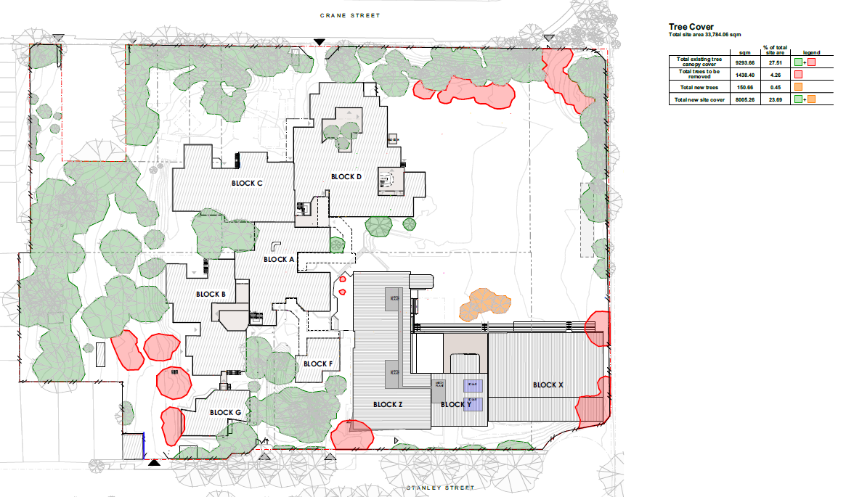

***Figure 5:*** *As per the tree Canopy Cover Plan, the proposal will remove 4.26% (red) of the site’s current tree cover of 27.51% (green and red combined). Replacement is indicated at 0.45% bring the total proposed tree cover down to 23.69%. The reduction is minimal and is not anticipated to have any adverse impacts on the landscape qualities of the site.*

* **Built Environment** –

The built form of Concord High School is a mix of late 1970s to early 1980s buildings that have been adapted over time to meet the changing needs of the school community and sit within a landscaped setting.

The proposed new development is sympathetic in its proposed form, proportions and, materials and finishes and responds well to the existing character of the school. The articulation and well-balanced presentation of the new buildings further ensure the proposal will not overwhelm surrounding residential development and public domain.

The new facilities are designed for maximum natural light and ventilation, are fully accessible incorporating ramps and lift access and incorporates sustainable features including the use of passive heating and cooling systems, energy-efficient lighting, and insulation, a rainwater harvesting system that collects and stores rainwater, which is then used for irrigation as well as drought tolerant planting selections.

Furthermore, the school's buildings and grounds are designed to be flexible and adaptable, so they can be easily modified to meet future needs. This approach ensures that the school can continue to evolve and grow over time without needing to undergo significant renovations or rebuilds.

* **Noise and vibration** – Noise and vibration impacts associated with the construction phase will be controlled via conditions of consent.

The school is existing and has been in operation since 1980. The intent of the proposal is to provide for a needed upgrade to the school for existing staff and student numbers, currently accommodated in temporary demountable classroom infrastructure noting the addition of new facilities will provide for an increase of 25 students and 6 staff.

The minor increase in students and staff is not likely to result in any notable additional acoustic or amenity impacts and the noise associated with the operational use of the school after construction is not anticipated to generally exceed current noise impacts. Furthermore, the new learning spaces are located further away from residential development compared to the location of the existing temporary demountable classrooms currently used.

Additionally, the Noise and Vibration Impact Assessment confirms that noise emissions from proposed Blocks X, Y and Z are predicted to comply with the relevant project noise emission criteria and therefore the development is not expected to generate adverse noise impact on noise sensitive receivers surrounding the site.

* **Social impact** – The upgrades to the school will expand its staff (by 6 additional staff) and student capacity (25 additional students). The expansion, albeit minor, will accommodate a growing population in the local area in line with relevant strategic policies and plans, which anticipates growth in the number of families with children in the Canada Bay area.

The upgraded school facilities and outdoor environments will provide for improved quality of learning and allow for future development opportunities. These benefits are likely to generate positive social and socio-economic benefits for students, staff and the wider community who will continue to have the opportunity to utilise joint share facilities within the site.

The NSW Department of Education currently provide a number of Concord High School facilities to the local community for after-hours use. These organisations include Inner West Physie and Dance, United Volleyball, Junior Basketball Academy, St Alexander Nevsky Russian School, Heartbeat Church, Next Nuri Church, Bengali Association and Inner West Motivate Sports.

* **Economic impact** – The applicant estimates that sixty (60) construction jobs and six (6) full time equivalent positions will be generated by the works. Potential opportunities for further teaching and support staff recruitment in the future will also have a positive economic impact for the local community following construction.

The cleaning, maintenance and other services required by the future students and staff will a generate long term employment as well as increased employment opportunities for staff and support staff following the minor expansion.

No attributed negative economic impacts are expected from the additional school buildings and redevelopment.

As per the above discussion, it is considered that the proposal will not result in any significant adverse impacts in the locality as outlined above.

* 1. **Section 4.15(1)(c) - Suitability of the site**

The proposed development has been assessed in relation to its environmental consequences, and in terms of State Environmental Planning Policy Resilience and Hazards (Chapter 4, Remediation of Land). Having regard to this assessment it is considered that the land is suitable for the intended development subject to conditions of consent.

* 1. **Section 4.15(1)(d) - Public Submissions**

The proposal was notified in accordance with the Council’s Community Participation Plan from 13 July 2023 until 3 August 2023. The notification period did not result in any submission being received by Council.

* 1. **Section 4.15(1)(e) - Public interest**

The proposal is generally consistent with the aim and objectives of relevant planning controls with adverse impacts mitigated. It promotes the coordinated and orderly, and economic use and development of the land being for an improved educational facility for the use of existing and future students and staff. As a result, the Regional Planning Panel may be satisfied that the development subject to conditions is consistent with the public interest.

1. **REFERRALS AND SUBMISSIONS** 
   1. **Agency Referrals and Concurrence**

The development application required referral to NSW Transport under SEPP (Transport and Infrastructure) 2021, s2.119 (Development with frontage to classified road). The development was also referred to the Canada Bay Design Review Panel.

There are no outstanding issues arising from the referral requirement subject to the imposition of the recommended conditions of consent being imposed.

**Table 5: Concurrence and Referrals to agencies**

|  |  |  |  |
| --- | --- | --- | --- |
| Agency | Concurrence/  referral trigger | Comments  (Issue, resolution, conditions) | Resolved |
| **Concurrence Requirements** (s4.13 of EP&A Act) | | | |
| Environment, Energy & Science Group within DPIE | S7.12(2) - *Biodiversity Conservation Act 2016* | The proposal does not trigger a referral. | N/A |
| **Referral/Consultation Agencies** | | | |
| RFS | S4.14 – EP&A Act  Development on bushfire prone land | The site is not located on bushfire prone land | N/A |
| Transport for NSW | SEPP (Transport and Infrastructure) 2021, s2.119 (Development with frontage to classified road) | TfNSW reviewed the proposed development and raised no objections subject to the submitted School Travel Plan is updated as per TfNSW comments. | Yes |
| Design Review Panel | Cl 28(2)(a) – SEPP 65  The proposal does not relate to a residents flat building and hence is not formally required to be reviewed by the Design Review Panel. However, by request of the RPP, the proposal was referred to the DRP for general comments in terms of design. | The DRP noted that the proposal has been subject to a number of Panel reviews including the State Design Review Panel with the architectural design and associated landscaping in its final phase.  The DRP was generally supportive of the proposal as presented at the meeting. | Yes (see discussion in Part 5 below) |
| **Integrated Development (S 4.46 of the EP&A Act)** | | | |
| RFS | S100B - *Rural Fires Act 1997*  bush fire safety of subdivision of land that could lawfully be used for residential or rural residential purposes or development of land for special fire protection purposes | The site is not located on bushfire prone land | N/A |
| Transport for NSW | S138 - Roads Act 1993 for works in the road reserve. | The development proposes to improve the Crane Street drop-off/pick-up area to encourage more students to use this facility.  Council’s traffic engineer has advised that as this work is outside of the site boundaries, it will not be considered as part of this application. Instead, a separate application to the  Local Traffic Committee via Council’s Traffic and Transport Department is required. The applicant has been advised accordingly. | N/A |
| Heritage NSW | S58 of the Heritage Act 1977 for demolition or works etc to an item listed on State Heritage Register or with an interim heritage order. | The site is not listed on the State Heritage Register | N/A |

* 1. **Council Officer Referrals**

The development application has been referred to various Council officers for technical review as outlined **Table 6.**

**Table 6: Consideration of Council Referrals**

|  |  |  |
| --- | --- | --- |
| Officer | Comments | Resolved |
| Engineering | Council’s Engineering Officer reviewed the amended stormwater concept plan and raised a number of issues.  The additional information submitted is satisfactory and no further issues are raised in terms of stormwater. | Yes |
| Traffic | Council’s Traffic Engineering Officer reviewed the proposal and raised no concerns in relation to traffic generation and car parking subject to recommended conditions. | Yes |
| Building | No objections subject to recommended conditions | Yes |
| Acid Sulphate Soils | No objections subject to recommended conditions | Yes |
| Noise | No objections subject to recommended conditions | Yes |
| Contamination | No objections subject to recommended conditions | Yes |
| Heritage | Council’s Heritage Officer reviewed the original proposal and raised concerns with the number of trees removed due to the proposed car park extension and the location of Block I (uniform shop).  The additional information submitted is satisfactory and no further issues are raised in terms of heritage. See discussion in part 5 below. | Yes |
| Landscape Architect | Council’s Landscape Architect reviewed the original proposal and raised concerns including the planting selection.  The additional information submitted is satisfactory and no further issues are raised in terms of landscaping/planting selection. See discussion in part 5 below. | Yes |
| Arborist | Council’s Arborist reviewed the proposal and raised concerns including the impact on trees from the car park extension and location of the OSD tank.  The additional information submitted is satisfactory and no further issues are raised in terms of impact on existing trees. See discussion in part 5 below. | Yes |

The applicant’s additional information is satisfactory. Originally raised issues have been resolved as discussed in Part 5 - Key Issues section of this report.

* 1. **Community Consultation**

The proposal was notified in accordance with the Council’s Community Participation Plan from 13 July 2023 until 3 August 2023. The notification period did not result in any submission being received by Council.

1. **KEY ISSUES**

The following key issues are relevant to the assessment of this application having considered the relevant planning controls and the proposal in detail:

* 1. **Building Height**

The proposal is non-compliant with Clause 4.3 Height of Buildings of the CBLEP 2013. Pursuant to the LEP, the site has a maximum building height of 8.5m with the proposal having a height of 18.29m. The non-compliance relates to 9.79m or 115%. The applicant has submitted a Clause 4.6 objection to vary the development standard.

**Resolution:** As discussed within this report above, the applicant’s written Clause 4.6 objection is well founded and demonstrates why strict compliance is both unreasonable and unnecessary under the circumstances of the case and that the proposed variation results in a better outcome for the site. Council therefore does not object to the building height variation sought.

5.2 **Heritage**

Council’s Heritage Officer raised concerns with the loss of numerous trees as a result of the proposed extension to the staff car park adversely impacting on the landscape qualities of the site with further impact on retained trees due to new drainage works including a very large OSD tank under the carpark, and construction of a new carpark surface as well as the relocation of Modular Block 1 (uniform shop) to the west of the staff car park as it would become a visually intrusive element. They recommended that the additional new car parking should be located elsewhere within the site; similarly, the uniform shop to also be relocated elsewhere within the site.

**Resolution:** The extension of the carpark is necessary to accommodate the functional, everyday use of the site. The extension of the existing carparking is preferable to the construction of additional parking elsewhere within the site, which would likely require greater removal of vegetation.

In response to the comments by Council’s heritage advisor, the applicant’s heritage advisor provided further information that identifies that the proposal retains those trees considered to be of higher significance and are more likely to be associated with significant periods of landscaping on the site being 1940s-1960s or circa 1978. Further, the majority of the trees in the area of the carpark extension as well as throughout the school grounds are retained, maintaining the landscaped character and amenity of the school grounds and notes the removal of individual trees is not considered to adversely impact on the landscape qualities of the site, nor its heritage significance.

In terms of the proposed new location of the uniform shop, the applicant’s heritage advisor notes the proposed new location is behind the existing substation on Stanley Street, which has limited visibility from the public domain. The proposed location is less visible from the public domain than the existing location, and as such this is not considered to have an adverse heritage impact. Block I is a modular, demountable building, and is also not likely to have an adverse impact on the trees in the vicinity.

As per the above, no further issues are raised, and the proposal is considered acceptable in terms of heritage impacts despite the loss of a number of mature trees.

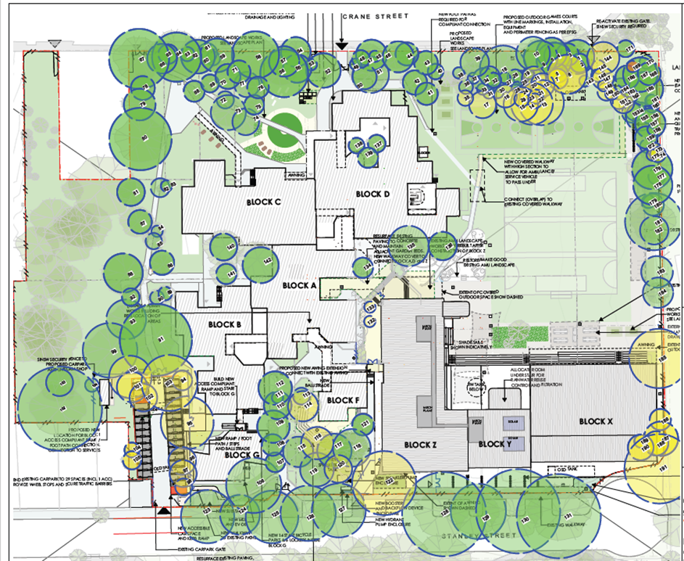***Figure 6:*** *The submitted Tree Location Plan by Birds Tree Consultancy identifies trees for removal in yellow. When compared to the level of tree canopy retained, it becomes clear that the landscape qualities of the site will be marginally impacted on.*

* 1. **Design Review Panel**

The DRP noted that the proposal has been subject to a number of Panel reviews including the State Design Review Panel with the architectural design and associated landscaping in its final phase.

The DRP was generally supportive of the proposal as presented at the meeting as any further design changes this late in the process would result in further delay of the project and additional cost though it did raise some minor concerns with the roof form over the Stanley Street main entrance, Roof over external staircases, and Interface between Block X and St Luke’s Oval. The DRP advised that although design changes relating to the aforementioned would improve the external built form, they are superficial modifications and not critical to the function of buildings and other associated structures.

**Resolution:** As the design phase was at an advanced stage at the time of the DRP review and the DRP did not raise any major design issues, it is not considered feasible to request SINSW to engage in further design amendments given the architectural form responds appropriately to the site and surrounding development as discussed within this report.

* 1. **Landscaping /Tree Removal**

The site is located within Turpentine Ironbark Forest habitat connectivity area. Hence, Council’s Landscape Architect recommended that new trees/plants are selected from the Turpentine Ironbark Forest planting list in Table B-R of the DCP. They also requested the applicant to provide a Tree canopy cover figure and the artificial turf to the cultural fire pit be replaced with a permeable surface.

It was also requested that a condition of consent be imposed on any development consent requiring non-destructive root exploration (NDRE) to be undertaken on a number of trees as recommended in the arborist report as well as relocation of the OSD tank to retain trees 7 and 8 and to utilise directional drilling to connect the OSD to the existing stormwater vault to mitigate impact on trees.

Concern was also raised regarding impacts arising from the hardstand required to support the proposed bike stand that had not been considered and it was recommended to relocate the bike stand to ensure viability of trees in this area.

**Resolution:** It is noted that no works are within the remnant Turpentine Ironbark Forest planting with no Turpentine species proposed for removal.

The proposed plant selection reflects the cultural plantings from the 1930’s tannery and 1970s to respect the heritage landscape nature and significance of the site. Given no existing Turpentine species will be removed, this is considered to be a more appropriate action to maintain the heritage significance of the site.

A Tree Canopy Coverage Plan has been submitted indicating existing and proposed canopy cover. Although the proposal will result in a loss of canopy cover on the site from existing 27.51% to 23.69% (including new trees), the overall reduction is relatively minor and will not result in any adverse visual impact in terms of landscape setting and will still provide substantial greenery and shade within the site.

The Cultural Fire Pit has been replaced with a Yarning Circle on a permeable surface area.

The bike stand has also been relocated in response to Council’s concerns.

SINSW has accepted NDRE to be imposed on relevant trees as recommended in the submitted Arborist Impact Statement via condition of consent.

In terms of relocation of OSD 2 to outside of the Tree Protection Zone (TPZ) of trees 7 and 8, the applicant has advised that this is possible however the required stormwater outlet is still required to connect to an existing pit to the northwest through the TPZ of a number of trees including trees 7 and 8.

The applicant has advised that the Project Engineers (Woollacotts) therefore explored an option to direct the stormwater outlet pipe from the revised OSD 2 location to the north (and within the works footprint of the new pathway). Dictated by existing site levels, Woolacotts identified a number of issues that confirmed the revised siting resulted in an inferior outcome for the site. Additional civil works would be required within the site (new Junction Pit inside the northern boundary) in addition to works within the Crane Street road reserve. Crane Street accommodates a number of services, and the new outlet pipe would need to traverse through the southern verge and connect to a new ‘On Road Pit’ in Crane Street. Trenching would need to be undertaken to determine the depth and location of services so that the Project Engineers could identify if the new outlet pipe could be installed to achieve the required fall to the north. Accordingly, Woolacotts confirmed that the original location for OSD 2 was preferred due to the scale of civil works required in the Crane Street road reserve and the unknowns associated with the depth/ location of services and likely clashes in Crane Street. The project team therefore requested to remove Trees 7 and 8 in accordance with the recommendations of the Arborist Report. To compensate for this loss SINSW will replace Trees 7 and 8 with two (2) semi mature species that will provide shade and amenity for students.

Council, upon considering the justification to retain trees 7 and 8 raises no further issues and consents to the removal of said trees subject to a condition requiring appropriate replacement trees is imposed on any development consent.

At the briefing meeting, the Regional Planning Panel recommended the use of alternate construction methods for the car park extension such as a permeable surface be investigated as a means of retaining trees in this area. This was subsequent discussed with the applicant who advised that due to cost, life span and ongoing replacement requirement it would not be a viable long-term solution. Council accepts this and did not require a redesign to this effect.

**5.4 Works in Road Reserve**

The development proposes to improve the Crane Street drop-off/pick-up area to encourage more students to use this facility with the following traffic calming measures:

* Installation of speed cushions, for controlling the speed of north-westbound traffic around the curve along Crane Street;
* Installation of regulatory and advisory signage, for clearer advisory of the area and advanced warning; and
* Implementation of additional road line marking, for guiding traffic away from the drop-off/pick-up area that may have vehicles stopping.

Concurrence of the relevant roads authority, in this circumstance being City of Canada Bay Council, is required. Council’s traffic engineer advised that a separate submission must be made to the Local Traffic Committee via Council’s Traffic and Transport Department seeking the Council’s approval for any changes to the road environment and that there is no guarantee that these works will be supported through community consultation and Local Traffic Committee/ Council meeting and that all costs associated with the implementation of these works shall be borne by the applicant.

1. **CONCLUSION**

This development application has been considered in accordance with the requirements of the EP&A Act and the Regulations as outlined in this report. Following a thorough assessment of the relevant planning controls, and the key issues identified in this report, it is considered that the application can be supported.

It is considered that the key issues as outlined in Section 6 have been resolved satisfactorily through amendments to the proposal and/or in the recommended draft conditions at **Attachment A**.

1. **RECOMMENDATION**

That the Development Application DA No 2023/0135 for *Demolition of some existing structures, construction of a new combined facility catering for administration, staff areas, General Learning Spaces, Support Classrooms, Specialty Classrooms, a new Hall and Canteen, refurbishment of the existing library, landscaping and perimeter fencing* at 5 Stanley Street, Concord NSW 2127 be APPROVED pursuant to Section 4.16(1)(a) or (b) of the *Environmental Planning and Assessment Act 1979* subject to the draft conditions of consent attached to this report at Attachment A.

The following attachments are provided:

* Attachment A: Draft Conditions of consent
* Attachment D: Architectural Plans
* Attachment E: Clause 4.6 Request